t

Task 3.1: Implementing Dynamic Features with JavaScript
Overview
In this task, I began adding simple dynamic behavior to my webpages using JavaScript. Used click events to display alert messages when users interact with different buttons and form elements. These features introduce the basic JavaScript skills that I will continue developing in later tasks.
Completed the following:
- Add a JavaScript alert for the Subscribe button in the footer of every webpage.
- On the Gallery page, add alert messages to the Add to Cart, Clear Cart, and Process Order buttons. These buttons act as placeholders for features you will build later. For this task, each button only needs to display a simple alert when clicked.
- On the About Us/Contact page, add a JavaScript alert to the Submit button on the contact form.
Each alert should activate through a click event and display one of the following messages:
• “Thank you for subscribing.”
• “Item added to the cart.”
• “Cart cleared.”
• “Thank you for your order.”
• “Thank you for your message.”
Finally, documented any issues or errors I encountered while developing my code. Remember that any component colors, font colors, and typography styling should be consistent with my choices in Task 1 and should be appropriate according to the client description provided in the client scenario criteria.

Instructions
Provide your responses in the following table.

Rendered Subscribe Feature Alert Window Screenshot.
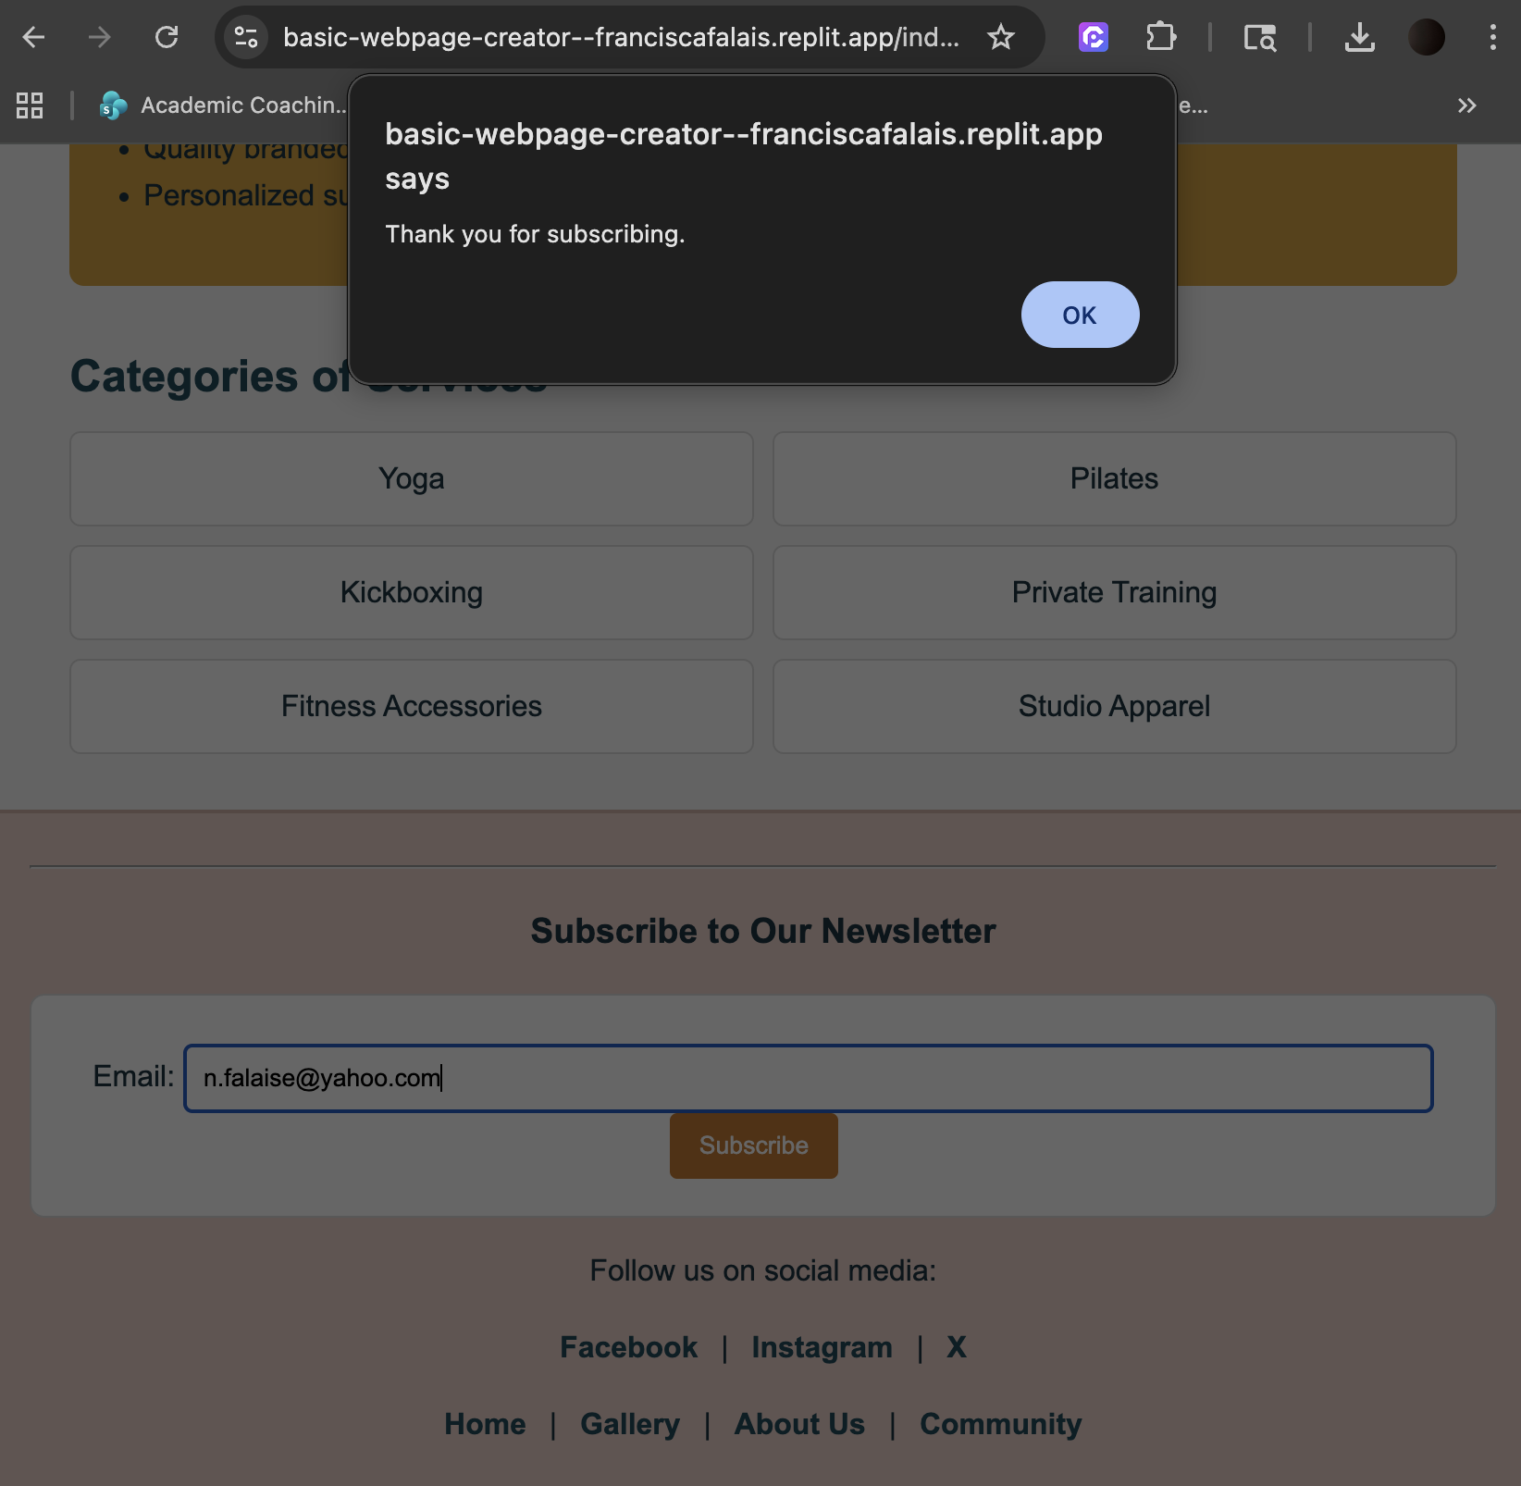

Subscribe Feature Alert Window Analysis
I implemented a click event handler for the Subscribe button located in the footer of each webpage. When a user clicks the Subscribe button, JavaScript triggers an alert that displays the message “Thank you for subscribing.”
To ensure consistency across the website, I assigned a shared class (.subscribe-btn) to all Subscribe buttons and used a query selector to apply the event listener to each one. This allowed the same functionality to work across all four pages without duplicating code. This approach improves code efficiency and maintainability by avoiding duplicate event handlers.

Rendered Add to Cart Button Alert Screenshot (Gallery Page)
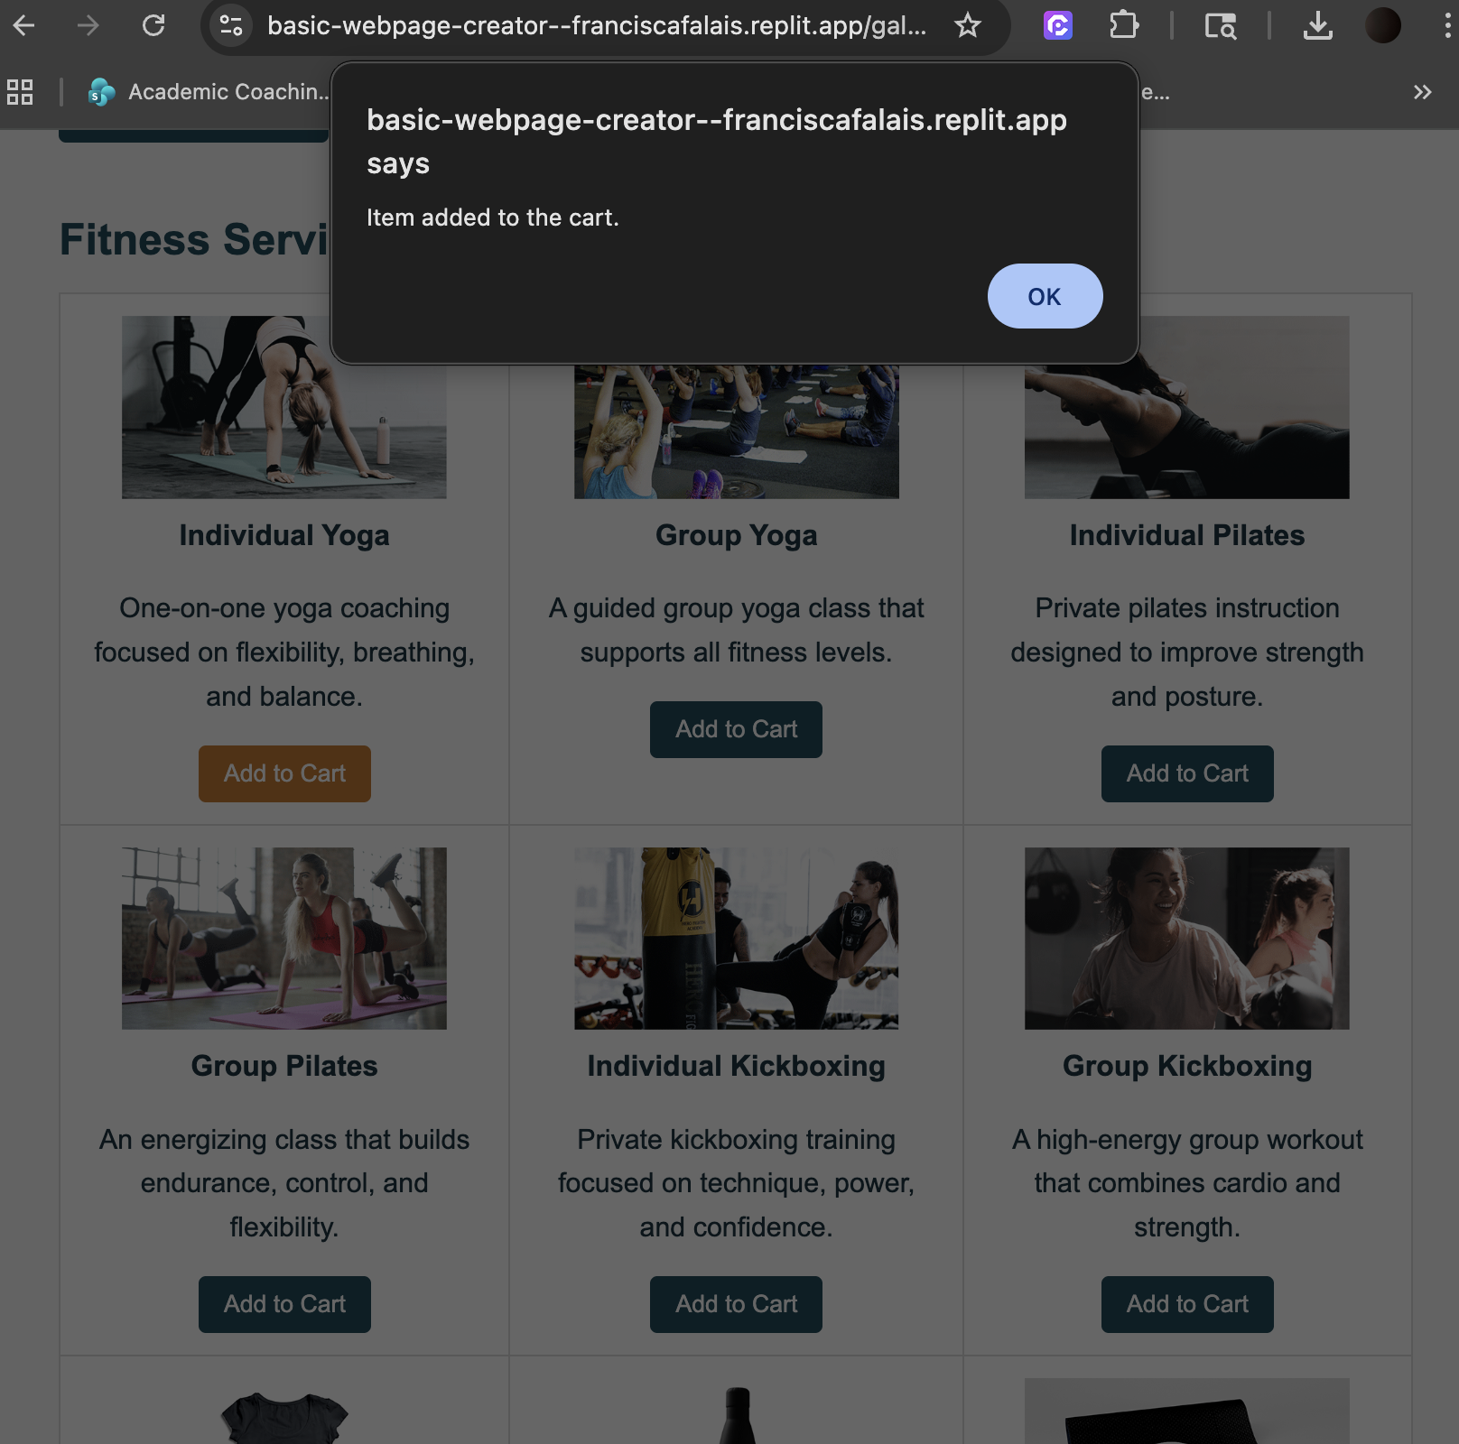

Add to Cart Button Analysis
On the Gallery page, I added click event listeners to all “Add to Cart” buttons. Each button is assigned a shared class (.add-cart-btn), allowing JavaScript to select and apply the same behavior to all of them.
When a user clicks any Add to Cart button, an alert appears with the message “Item added to the cart.” This confirms that the button interaction is working correctly.
This feature is currently a placeholder and does not include actual shopping cart functionality, as that will be implemented in a later Touchstone task.

Rendered Clear Cart Button Alert Screenshot (Gallery Page)
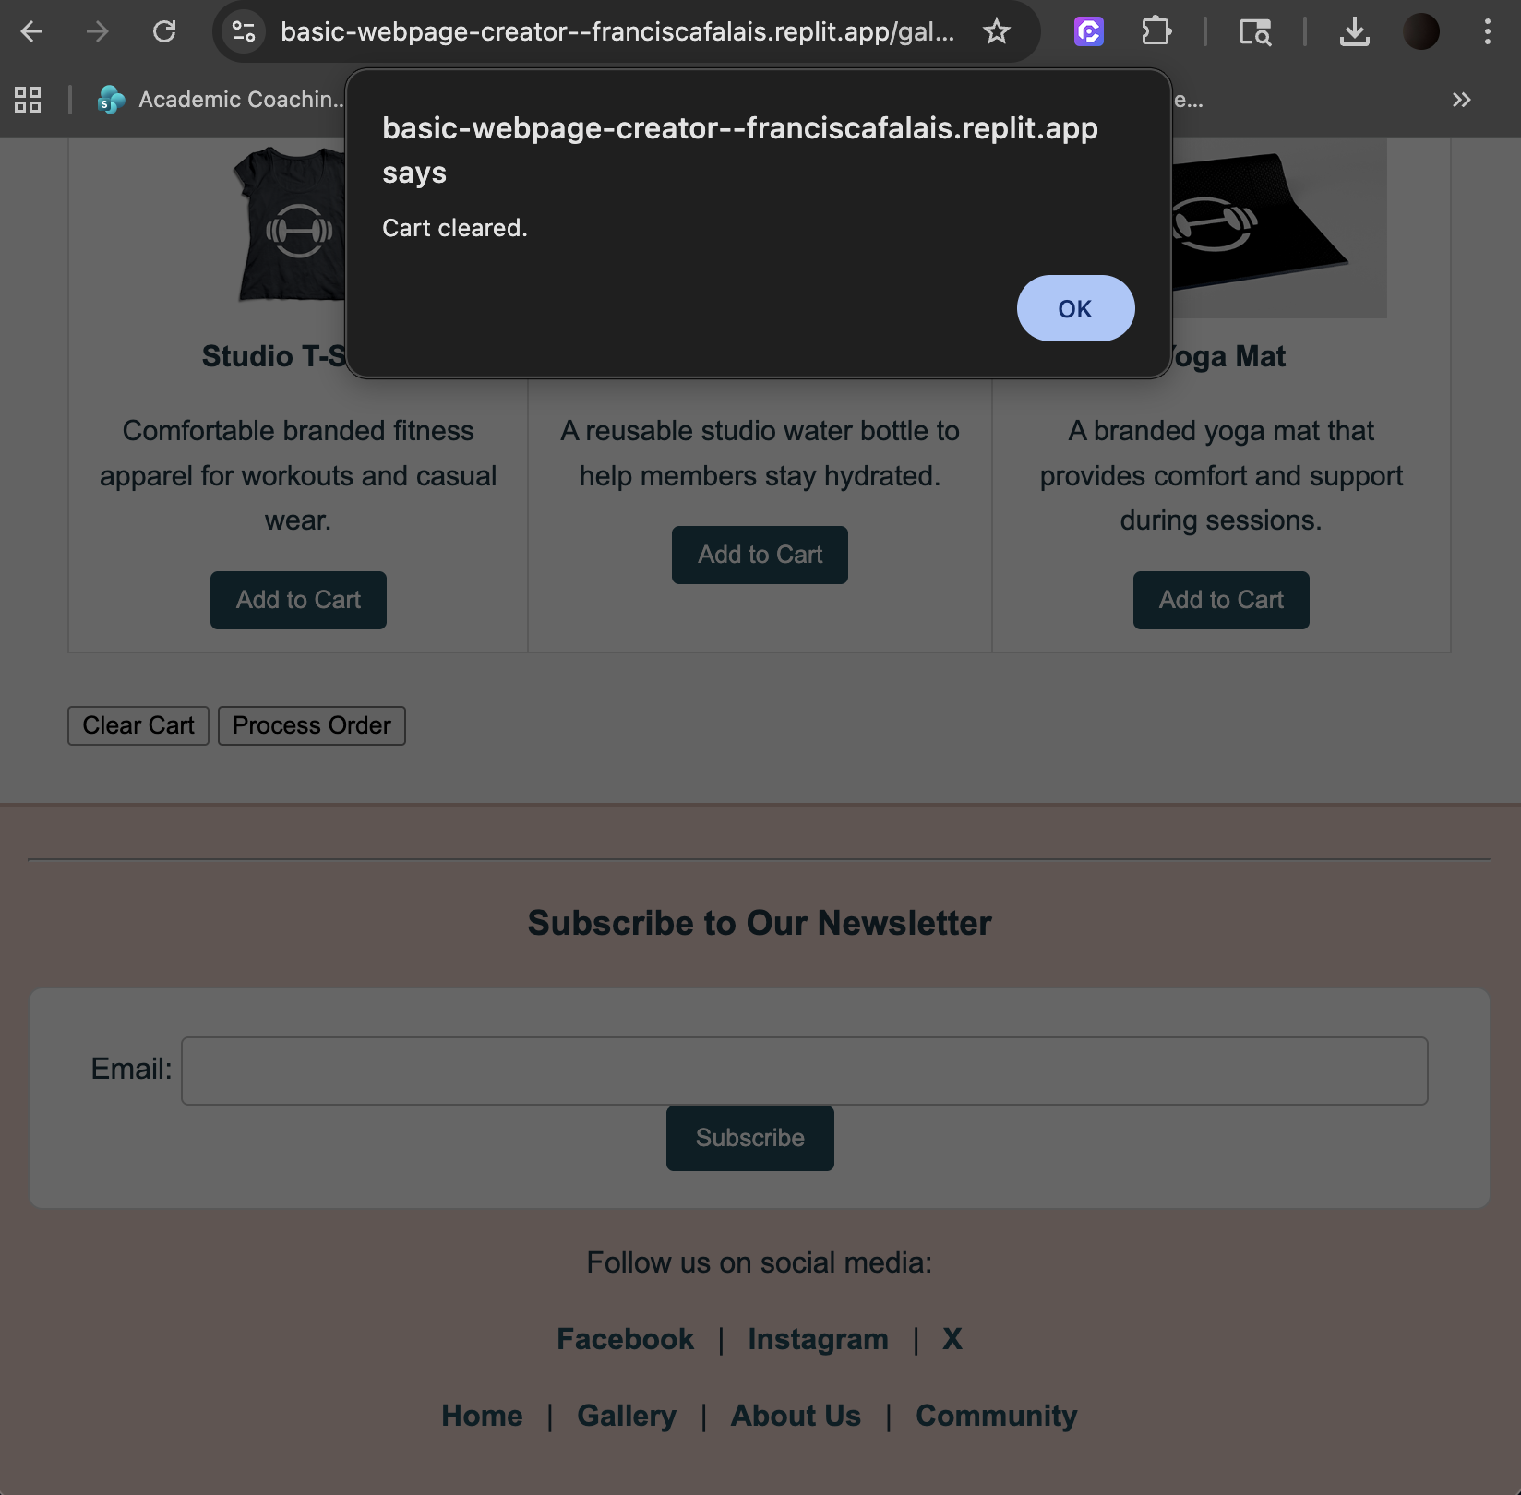

Clear Cart Button Analysis
I added a click event listener to the Clear Cart button on the Gallery page using its unique ID (#clear-cart-btn).
When the button is clicked, JavaScript displays an alert with the message “Cart cleared.” This provides feedback to the user that the action was triggered successfully.
Like the Add to Cart feature, this is a placeholder and does not remove actual items.

Rendered Process Order Button Alert Screenshot (Gallery Page)
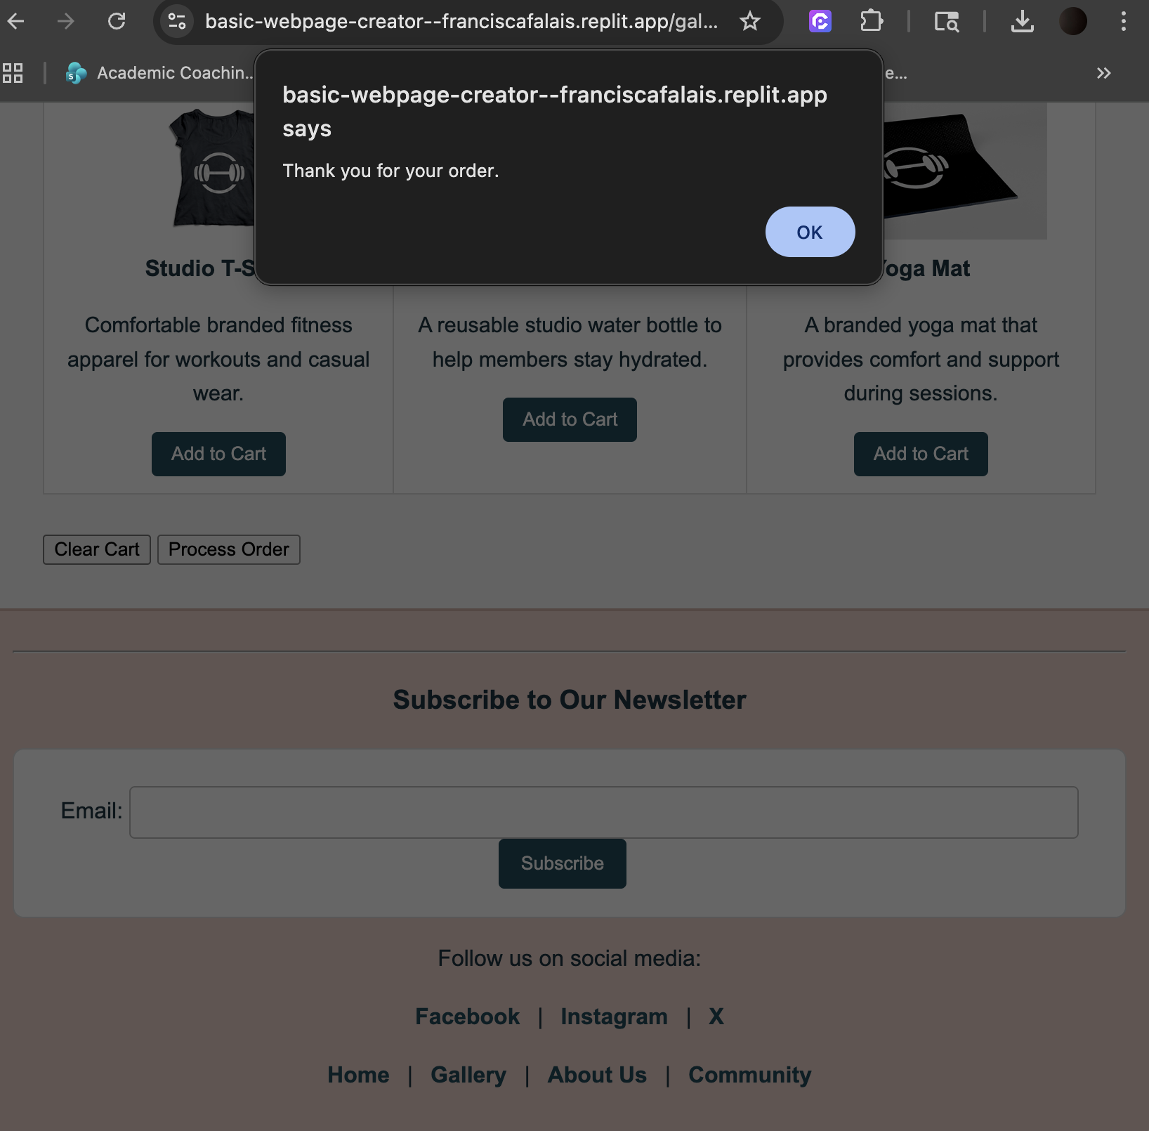

Process Order Button Analysis
The Process Order button also uses a click event listener tied to its ID (#process-order-btn).
When clicked, the alert message “Thank you for your order.” is displayed. This simulates the completion of a purchase and confirms that the interaction is functioning properly.
This feature serves as a placeholder for future checkout functionality.

Rendered About Us/Contact Page Form Submission Alert Window Screenshot
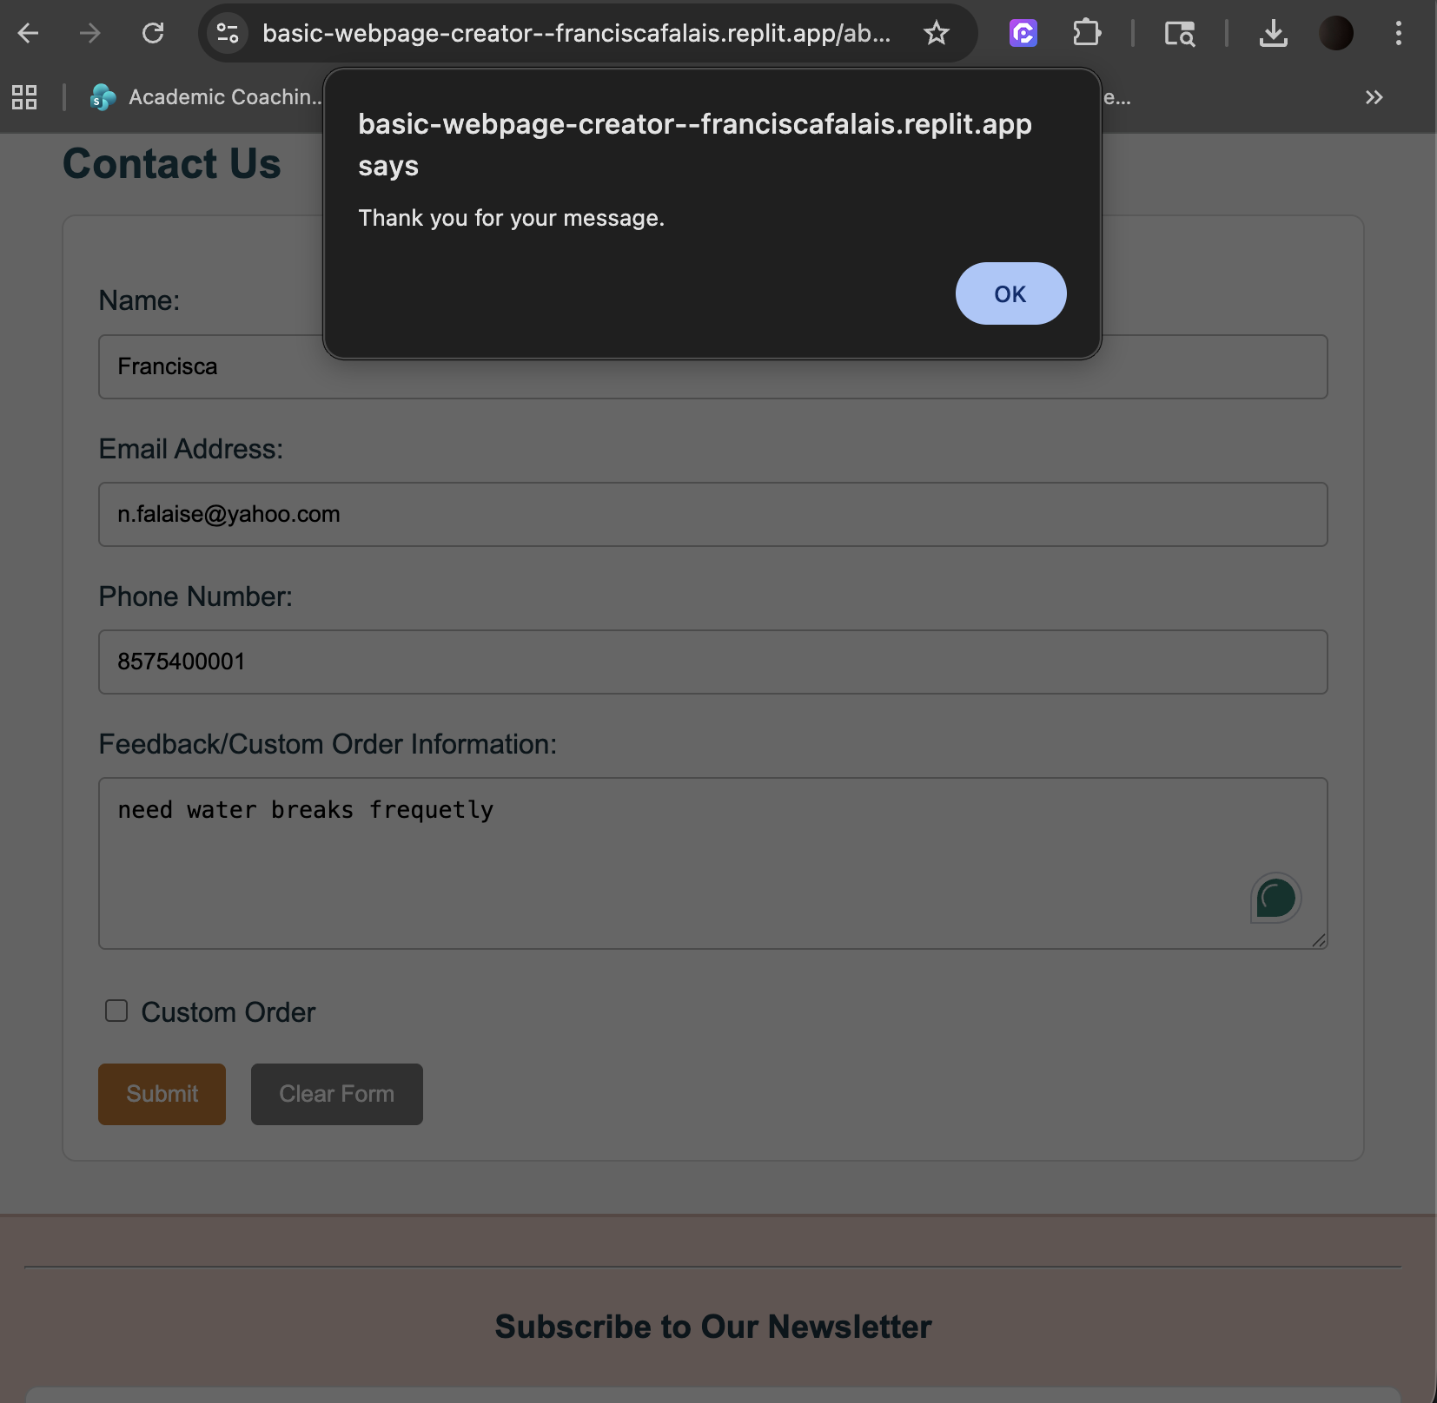

About Us/Contact Page Analysis
On the About Us page, I implemented JavaScript functionality for the contact form. The form has an ID (#contact-form), and an event listener is attached to the form submission event.
When the user submits the form with all required fields completed, JavaScript displays an alert with the message “Thank you for your message.”
The form submission is prevented from reloading the page using event.preventDefault() so that the alert can be displayed clearly.

Rendered About Us/Contact Page Input Validation Screenshot
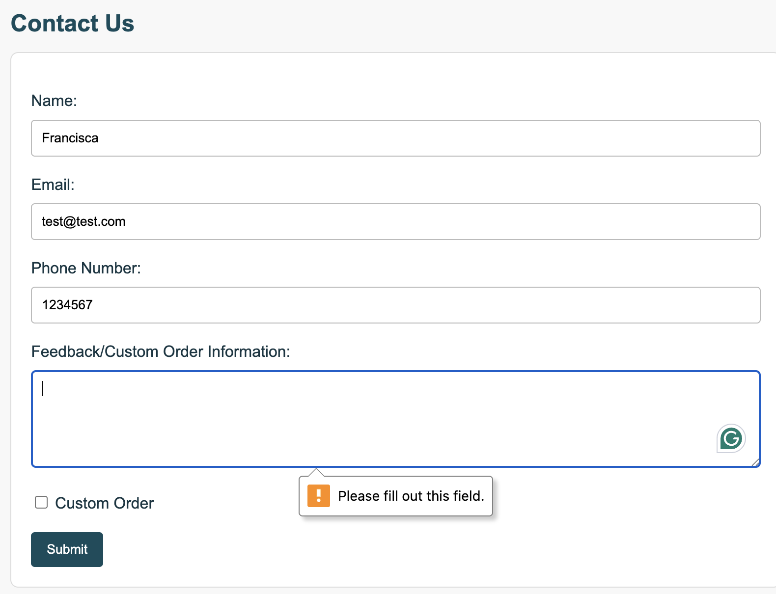

About Us/Contact Page Input Validation Analysis
Hint: Briefly describe what happens when the form is submitted with missing information. The validation messages you see are created by the browser because the form fields use HTML attributes such as required. No additional JavaScript is needed to produce these message.
I used built-in HTML form validation by adding the required attribute to the Name, Email, and Feedback fields.
If a user attempts to submit the form without completing these fields, the browser automatically displays validation messages such as “Please fill out this field.”
This validation is handled by the browser and ensures that users provide the necessary information before submission without requiring additional JavaScript logic.

Testing and Error Reporting

Recorded the details of the error from the IDE here. During development, I encountered an issue where the JavaScript code was not working as expected. The error occurred because some elements were being accessed before the page had fully loaded, resulting in null reference errors.
Describe what you attempted in order to fix the error.
To fix the issue, I ensured that the JavaScript file was properly linked at the bottom of each HTML page. I also used the DOMContentLoaded event to make sure the script runs only after all elements have loaded.
After making these adjustments, all buttons and form interactions worked correctly, and the alert messages displayed as expected.

